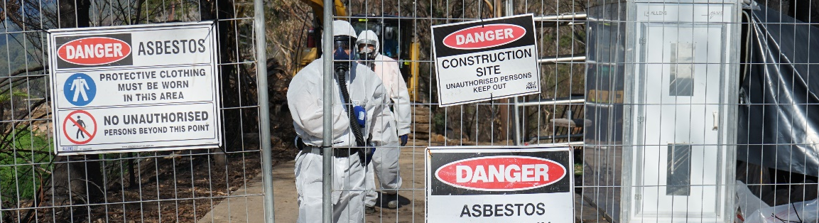

ASBESTOS REMOVAL
PERMIT
Permit Conditions
This permit is required for all friable and non-friable asbestos removal works. This permit can be issued for the duration of the asbestos removal scope of works. Where the scope of works changes or a new scope of works is to be completed a new Asbestos Removal Permit is required to be issued.
This permit is NOT required for the management unexpected finds where these are managed through the unexpected finds procedures, those involved hold the required competencies and any items are disposed of in line with legislative requirements.
PERMIT Number:
Project:
WORK IS NOT TO COMMENCE UNTIL A SIGNED AND APPROVED PERMIT IS ON THE WORKSITE
PART A: Permit Application (Completed by persons intending to remove asbestos)
Name: |  |  | Company:
Contact Number: |  |  | Date:
Proposed Works / Permit Scope:
Location:
(Plan attached) Drawing/Sketch No.:
Work Commencement Date: |  | dd/mm/yy | Time: | XX:XX am/pm
Work Completion Date: |  | dd/mm/yy | Time: | XX:XX am/pm

PART B: Safe System of Work (Completed by Authorised Engineer/ Applicant)
 | Yes | No | N/A
Is the Site Specific Asbestos Removal Control Plan for this activity consistent with Model Code of Practice How to Safely Remove Asbestos Appendix B Asbestos Removal Control Plan Contents OR Compliance Code Removing Asbestos in the Workplace Appendix K for Victorian projects? | ☐ | ☐ | ☐
Does the company engaged, hold the relevant class of licence for the type of asbestos being removed (e.g. removal of non-friable vs friable)? | ☐ | ☐ | ☐
Have the competencies for those undertaking/supervising the asbestos removal works been verified as meeting national competency requirements? | ☐ | ☐ | ☐
Has the Regulator Notification for Asbestos Removal been completed and provided? | ☐ | ☐ | ☐
Has a Safe Work Method Statement for asbestos removal works been developed and accepted? (Copy of SWMS to be attached) | ☐ | ☐ | ☐
Are there any isolation required for the removal works e.g. electrical isolations where water will be used for dust suppression? | ☐ | ☐ | ☐
Is there adequate lighting available for the asbestos removal works to be undertaken? | ☐ | ☐ | ☐
Has a hygienist been engaged to conduct air monitoring where relevant and as per the Asbestos Removal Control Plan? | ☐ | ☐ | ☐
Are decontamination facilities available for the asbestos removal work area, any plant used in that area and workers carrying out the asbestos removal work? | ☐ | ☐ | ☐
Is the waste facility identified for receiving this waste licenced to receive the waste type generated e.g. friable vs non friable vs soil containing ACM. | ☐ | ☐ | ☐
Has an Independent Asbestos Assessor been engaged to complete the clearance certificate(s) (where this is required)? | ☐ | ☐ | ☐

PART C: Approval & Acceptance (Completed by Permit Issuer and Holder)
Permit Commencement Date: | dd/mm/yy |  |  | Time: |  | XX:XX am/pm
As the Permit Issuer, I Authorise the Asbestos Removal Works to commence in accordance with the Permit Request and Permit conditions outlined above.
Permit Issuer Name: |  | Signature |  |  | Date
Comments:

As the Permit Holder, I confirm that:
- A physical walk through has been undertaken with the Responsible Engineer/Supervisor and Permit Issuer;
- I fully understand the requirements of this permit including how to comply with the conditions and controls outlined in the permit; and
- I have undertaken the required Laing O’Rourke permit to work training and I am an authorised Permit Holder.
Permit Holder Name:
Signature |  | Date |  | dd/mm/yy | Time |  | XX:XX am/pm

PART D: Permit Induction (Completed by Permit Holder with Work Crew)
As a member of the Work Crew, I confirm:
- A physical walk through has been undertaken with the Permit Holder;
- I have been briefed / consulted with and understand the conditions of this permit and the asbestos removal control plan;
- I understand and will follow all requirements, conditions listed here within; and
- I have signed onto the SWMS and will follow the control measures listed.
Inductee Name |  | Employer | Position |  | Date |  | Signature
PART E: Permit Closure (Completed by Permit Holder and Permit Issuer)
Works are complete | ☐ Yes | ☐ No |  | Work site is in a safe condition: |  |  | ☐ Yes | ☐ No
Sign Off
Permit Holder Name: |  |  | Signature: |  |  | Date: |  | dd/mm/yy
Permit Issuer Name: |  |  | Signature: |  |  | Date: |  | dd/mm/yy

