 | RAIL WHEEL INSPECTION  FORM

PROJECT NAME |  | PROJECT NO
ASSET NO |  | DATE
ASSET MAKE AND MODEL |  | SERIAL NUMBER
LOCATION |  | SERVICE TYPE
JOB CARD NO |  | WORK ORDER NO
ODOMETER READING |  | HOUR METER READING
LAST SERVICE DONE | Date | Type

- This Inspection Sheet contains inspections relevant to the Rail Guidance System components of the asset only and is to be used in conjunction with an asset specific Service Sheet as applicable.
- Refer to previous inspection/service for relevant information.
- Ensure machine access is available prior to inspection due date.
- Consult operator for machine feedback and assistance with inspection if required.
WARNING
- Refer to the workshop manual or the Maintenance Supervisor for assistance if you are unsure of any portion of this inspection checklist.
- If you are unsure of the correct Tag Out Procedure do not proceed with this service - report to the Maintenance Supervisor for assistance.
- Relieve all residual pressures in the air and hydraulic systems and ensure machine is unable to roll away.
- Machines should be washed down prior to inspection. Pay particular attention to areas being inspected.
- Before inspecting the machine, stop the engine and apply parking brake, unless otherwise specified. Ensure wheels are chocked (where applicable).
- Read and understand all warning plates on the machine before operating, lubricating or repairing the machine.
- Be aware of hot components and fluids on machines which have just stopped.
For a comprehensive list of inspection instructions, refer to the OEM operation and maintenance manual for the type / model of the machine.
RIM / AQUIPA CURRENT DUE DATE |  | CURRENT RIM / AQUIPA STICKER OR LABEL APPLIED | ☐ YES ☐ NO ☐ N/A
ANNUAL INSPECTION  DUE DATE |  | CERTIFIED NETWORKS
SERVICE STICKER FITTED AND DUE DATE |  | MEASURING DEVICE TYPE
 |  | SERIAL / CALIBRATION NUMBER
 |  | CALIBRATION DATE

APPLICATION OF THE STEEL WHEEL MEASURING GAUGE
Note that all steel wheel measuring gauges are identified with a unique number prefixed with the letters “MG”. The gauge must be inspected for calibration and any obvious sign of damage prior to use. If found to be out of calibration or damaged, return to the nearest Select Workshop for replacement. Record all measurement taken on this form.
The following demonstrates how each measurement type must be taken.

RIM THICKNESS
Position steel wheel gauge against back of flange, at right angle to tread face, with base of gauge pointing towards centre of wheel. Whilst ensuring gauge is against back of wheel, take measurement as shown in Figure 1.

LIMITS
Axle loads up to 25 tonnes | Not to be less than 20 mm
Track West (former Aries)  up to 5 tonne axle load | Not to be less than 14 mm

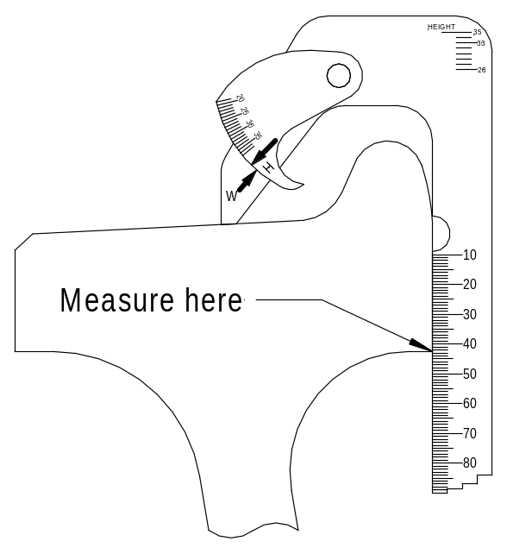
Figure 1 Use of Steel Wheel Measuring Gauge - Rim Thickness

WHEEL MEASUREMENTS
Left Front 1 |  | Right Front 1
Left Front 2 |  | Right Front 2
Left Satellite |  | Right Satellite
Left Rear 1 |  | Right Rear 1
Left Rear 2 |  | Right Rear 2
Left Match Wagon |  | Right Match Wagon

FLANGE WIDTH
Without moving stock of gauge from above position, rotate swing arm until it touches the inner face of flange. The measurement point is the arrow at ‘W’.
LIMITS
All wheels | Not to be less than 19 mm
NOTE: If reading is 21 mm or less check wheel with the Standard Wheel Condemn Gauge.
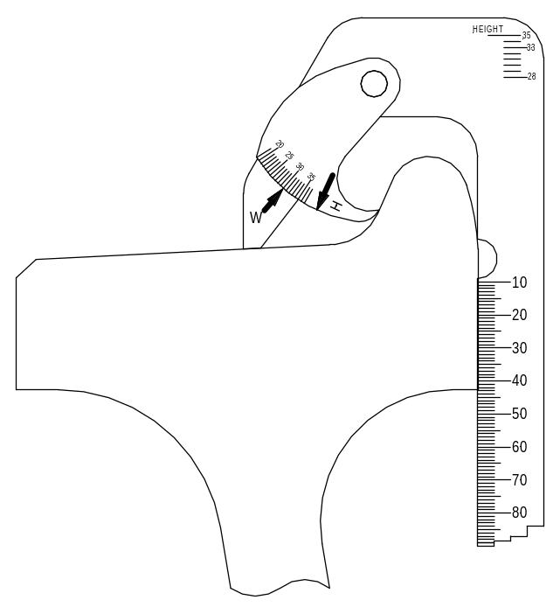
Figure 2 Use of Steel Wheel Measuring Gauge – Flange Width

WHEEL MEASUREMENTS
Left Front 1 |  | Right Front 1
Left Front 2 |  | Right Front 2
Left Satellite |  | Right Satellite
Left Rear 1 |  | Right Rear 1
Left Rear 2 |  | Right Rear 2
Left Match Wagon |  | Right Match Wagon

FLANGE HEIGHT
Leaving stock of gauge in the above position, rotate swing arm in a clockwise direction until it contacts the top of flange. The measurement point is the arrow at ‘H’. The scale on the gauge is read in millimetres. Note that the term “Tread Wear” and “Flange Height” is used concurrently by industry to describe the radial difference between a point at the extremity of the flange and a point at the centreline of the wheel tread.
LIMITS
All wheels | Not to be more than 35 mm
NOTE: If reading is 33 mm or more check wheel with the Standard Wheel Condemn Gauge.
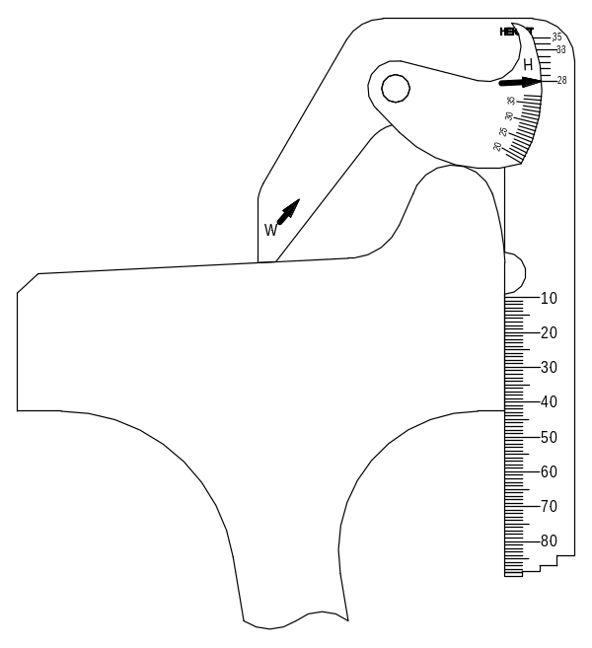
Figure 3 Use of Steel Wheel Measuring Gauge - Flange Height

WHEEL MEASUREMENTS
Left Front 1 |  | Right Front 1
Left Front 2 |  | Right Front 2
Left Satellite |  | Right Satellite
Left Rear 1 |  | Right Rear 1
Left Rear 2 |  | Right Rear 2
Left Match Wagon |  | Right Match Wagon

APPLICATION OF RAIL WHEEL GAUGE
The rail wheel gauge (Image 1) must be inspected for any obvious sign of damage prior to use.
If found to be damaged, return to the nearest Select Workshop for replacement. Record all measurement taken must be entered on this form.
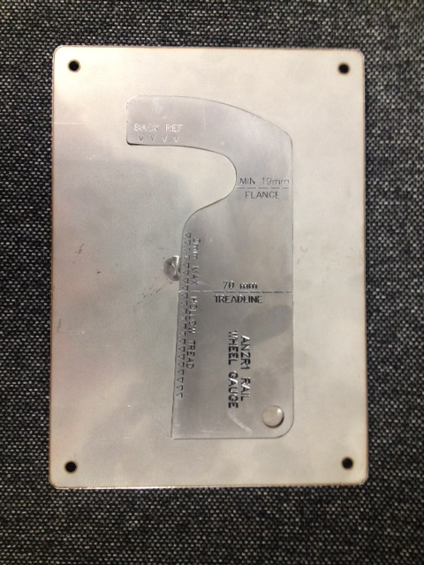
Image 1 Rail wheel gauge

TREAD HOLLOWING
Visual examination of the wheel tread is necessary to determine the presence of hollow tread.
This condition results in the loss of effective wheel conicity that produces high flanges and significantly reduces the tracking ability of a bogie.
The amount of tread hollowing is measured by applying a straight edge across the wheel tread so that the inner edge is near the root of the flange and 90 mm from the rim face.
The gap between the straight edge and the wheel tread is measured and if it is more than 3 mm, the vehicle must be marked "For Repair". The straight edge may be any convenient item, the extended leg of the standard wheel gauge being a suitable device. No speed restriction is required.
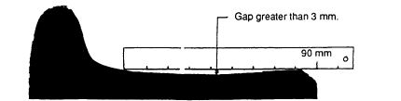
Figure 3 Measurement of Hollow Tread

WHEEL MEASUREMENTS
Left Front 1 |  | Right Front 1
Left Front 2 |  | Right Front 2
Left Satellite |  | Right Satellite
Left Rear 1 |  | Right Rear 1
Left Rear 2 |  | Right Rear 2
Left Match Wagon |  | Right Match Wagon
On a new profile, the tread surface is flat at a gradient of 1:20 fall toward the inside rim face away from the flange. The wheel will wear on the contact band between the wheel and the railhead and hence tread hollowing will develop.

WHEEL SET BACK-TO-BACK GAUGE
The back-to-back dimension of a wheel set must be checked:
- at all scheduled inspections
- after any derailment
- at any other time, the wheel condition may indicate a bent axle or incorrectly positioned wheel.
These conditions are sometimes indicated by visible misalignment in wheel rotation or uneven wear patterns on the flange or tread.
All measurement taken shall be recorded on this Rail Wheel Inspection form.
The back-to-back dimension must be gauged at not less than three (3) locations equally spaced around the rim of the wheels, at a point 40mm below the outer circumference of the wheel flange and should be within the range of: Note: The competent person must check the measurements are aligned with the relevant Network owners requirements.
Narrow Gauge (1067mm, 3ft 6 in) – Back-to-back gauge | = | 990 to 992mm
Note - PTA | = | 992 to 993mm
Standard Gauge (1435mm, 4ft 8 ½ in) – Back-to-back gauge | = | 1357 to1360mm
Broad Gauge (1600mm, 5ft 3 in) – Back-to-back gauge | = | 1522 to 1525mm
The back-to-back dimension shall be measured from the flat gauge side face of the wheel tread ensuring that the radius leading to the flange is not included in the measurement.
A variation of 3 mm or more between any of the back-to-back dimensions on a single wheel set may indicate a bent axle or distorted wheel and further examination is required. This wheel set must be forwarded to an appropriate repair facility for further inspection (e.g. checking by spinning between centres, run-out with dial gauges.)
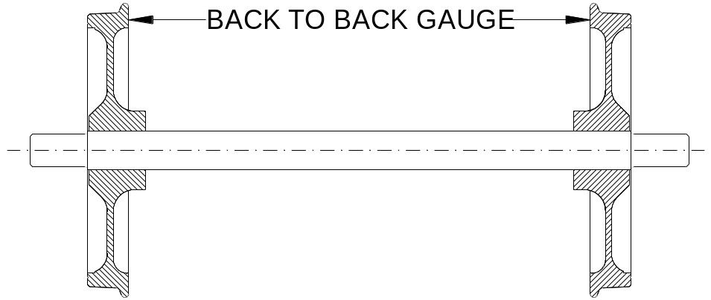Figure 5 Measurement of Hollow Tread

WHEEL MEASUREMENTS
Front 1
Satellite
Rear 1
Match Wagon

PTA WHEEL MEASUREMENT TABLE
Measure the back-to-back dimension of all wheelsets.
mm
Axle 1 back-to-back
Axle 2 back-to-back
Axle 3 back-to-back
Axle 4 back-to-back

WHEEL SET DERAILMENTS
Whenever a wheel set is involved in a derailment or similar incident, each wheel must be given a thorough examination to identify any potential defects that may have resulted.
Such examination must include a complete back-to-back gauge check of each wheel set involved in the derailment and measurement recorded on this Rail Wheel Inspection Form.
The examination should also include a bearing rotation test to assess whether any bearing damage has occurred.
Approval for the wheel set to continue in service must be given by a competent person from Select.
WORK IDENTIFIED OR NOT COMPLETE
DESCRIPTION | PRIORITY | NEW WORK ORDER
COMMENTS | ACTIONS

SIGNATURES / APPROVALS
Inspection Completion Declaration
Upon signing this Inspection report you deem that this inspection has been thoroughly completed.
The machine is in a safe and operational condition at the time of inspection/service and ALL RIM requirements have been met for certification.
Inspected by  (Name and Signature of competent Person) |  | Date  (Inspection  Completion Date)
Inspected by  (Name and Signature of competent Person) |  | Date  (Inspection  Completion Date)
Approved by  (Name and Signature of  Line Manger) |  | Date
Information entered into the CMMS by  (Name and Signature) |  | Date
Reviewed by  (Name and Signature  Rail Plant Manager) |  | Date
NOTES

