  SERVICE ISOLATION  PERMIT | 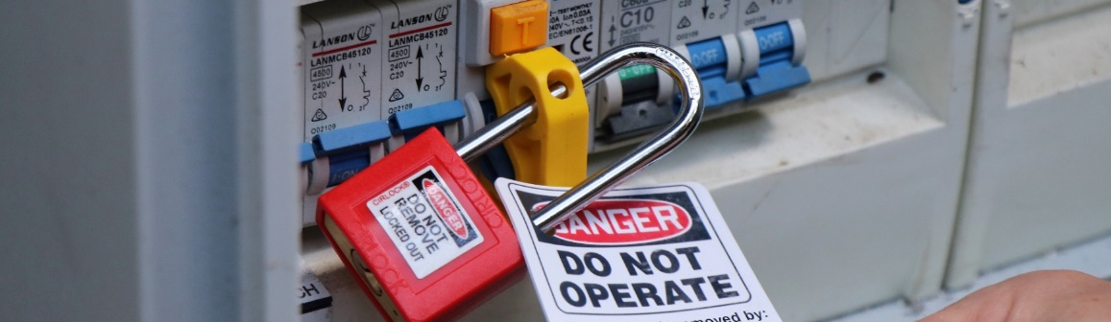
Permit Conditions
This permit is required for all tasks requiring services to be isolated, to control hazardous energy.
The permit can be issued for the duration of the defined scope of works. If the scope of works changes, or a new scope is proposed, a new Service Isolation Permit must be issued.
PERMIT Number:
Project:
WORK IS NOT TO COMMENCE UNTIL A SIGNED AND APPROVED PERMIT IS ON THE WORKSITE
PART A: Permit Application (Completed by persons isolating the service)
Applicant Name: |  |  | Company (if not LOR):
Contact Number: |  |  | Date:
Permit Holder Name: |  |  | Company (if not LOR):
Contact Number:
Work Area and Location:
Description of Works:
Equipment/Service to be Isolated:
Reasons for Isolation:
Required Date: | dd/mm/yy |  |  | Required Date: |  |  | XX:XX am/pm
Energy Sources Identified: | ☐ Electrical  ☐ Radiation | ☐ Chemical  ☐ Mechanical |  |  | ☐ Pneumatic  ☐ Hydraulic | ☐ Other (Specify):

PART B: Investigation (Completed by Permit Applicant/Permit Issuer)
Item | Yes | No | N/A
SWMS completed, reviewed, accepted and communicated to lock holders/stakeholders? | ☐ | ☐ | ☐
Marked up drawings/diagrams/schematics of the affected systems and area attached to application? | ☐ | ☐ | ☐
Work area(s) has been visually inspected? | ☐ | ☐ | ☐
All equipment requiring isolation has been identified? | ☐ | ☐ | ☐
All energy sources and controls have been identified? | ☐ | ☐ | ☐
Additional detailed information attached (if required)? | ☐ | ☐ | ☐
Details of Testing equipment to Verify isolations (Calibration date/ Model/ Serial #)? | ☐ | ☐ | ☐
Simple Isolation (Single Point Isolation)? | ☐ | ☐ | ☐
Complex Isolation (Lock Box/Group Isolation)? | ☐ | ☐ | ☐
All stakeholders have been notified? | ☐ | ☐ | ☐

PART C: Approval & Acceptance (Completed by Permit Issuer and Holder)
I confirm the above information has been checked and verified.
Permit Issuer Name: |  | Signature: |  | Date: |  | Time:
Permit Holder Name: |  | Signature: |  | Date: |  | Time:

ISOLATION INFORMATION
Isolation Point ID | Isolation Type  (Electrical/Mechanical) | Description |  | Item Location | Installed  Yes / No |  | Service Isolation Lock No. | Authorised Isolator
 |  |  |  |  | TAG | LOCK | Service Isolation Lock No. | NAME | DATE | TIME

ISOLATION VERIFICATION
I confirm that all isolations have been checked and are correct and effective
Authorised Isolator 1 Name: |  | Position: |  | Signature: |  | Date: |  | Time:
Authorised Isolator 2 Name: |  | Position: |  | Signature: |  | Date: |  | Time:
PERMIT ISSUE AND AUTHORITY TO COMMENCE WORKS
Authorised Isolator Name: |  | Position: |  | Signature: |  | Date: |  | Time:
Permit Holder Name: |  | Position: |  | Signature: |  | Date: |  | Time:

LOCK BOX DETAILS (COMPLEX ISOLATIONS)
Lock Box No | Service Isolation Permit No. |  | Authorised Isolator
 |  |  | Name: |  | Signature
 |  |  | Name: |  | Signature

PART D: Permit Induction and Lock Holder Sign On/Off
I acknowledge that I have been briefed on the above controls and isolations and I have placed my Personal Danger Lock and Tag on the Isolation Point or Lock Box.
Name | Employer | Date | Time | Signature On |  | Signature Off

ISOLATION / LOCK BOX TRANSFER |  |  |  | (Transfer of Control)
OUT-GOING PERMIT HOLDER  I can confirm that all isolations are correct as per this permit |  |  |  |  |  |  |  |  |  | IN-COMING PERMIT HOLDER  I can confirm that all isolations are correct as per this permit
Name |  | Signature |  |  | Date | Time |  |  | Name |  |  | Signature |  | Date |  |  | Time
Comments

PART E: Isolation Removal Confirmation / Permit Closure (Completed by Permit Holder, Authorised Isolator and Permit Issuer)
Prior to restoring equipment to service, check the following:
☐ | Ensure that non-essential items have been removed from machine or equipment; |  |  |  |  |  |  | ☐ |  |  | Remove all lockout devices and tags. Re-instate guarding/covers;
☐ | Ensure that all workers are at a safe distance before re-energising; |  |  |  |  |  |  | ☐ |  |  | Notify all stakeholders that equipment is ready for use.
Permit Holder: |  |  |  |  | Signature: |  |  |  | Date: |  |  |  |  | Time:
Authorised Isolator: |  |  |  |  | Signature: |  |  |  | Date: |  |  |  |  | Time:
We confirm that all isolations have been removed and equipment is restored to a safe operational state: |  |  |  |  |  |  |  |  |  |  |  |  | This permit is now closed |  |  | ☐

All personnel have been advised of service reconnection and service isolation register updated
Permit Issuer: |  | Signature: |  | Date: |  | Time:

