LIFTING OPERATIONS PLAN
TEMPLATE

Project Details
Project
Date

Contents
1. Introduction 2
2. Documentation, Inspection and Maintenance 2
3. Safe Working Load 2
4. General Lifting Conditions 2
5. Common Lifts 3
6. The Authorised Crane Team Members 4
7. Identification and Initial Assessment of Lifting Operations 6
8. Schedule of Common Lifts (Basic Lifts) 7
9. Schedule of Common/Basic Lifts 8
10. Project Arrangements for Procurement of Lifting Equipment 9
11. Crane Team Communication 9
12. Site Layout and Crane Location Drawings (Add to this section) 9
13. Appendix A - Appointed Person for Lifting Operations 10
14. Appendix B - Appointment Laing O’Rourke Crane Supervisor 11
15. Appendix C - Crane Team Meeting Agenda Template 12

Introduction
This Lifting Operations Plan details the project specific organisation and arrangements for the management of lifting operations on the above named project
Lifting operations include those carried out by mobile cranes, Vehicle Loading Cranes, excavators, forklifts, gantries, telehandlers and other such equipment when being used as a crane to lift or lower loads.
The responsibility for compiling, updating and reviewing this document rests with the ‘Appointed Person’ as defined in the Primary Standard “PS Cranes and Lifting” and who is named in the Project Health and Safety Plan – Laing O’Rourke Construction Australia (LORAC).
The development and complexity of Lifting Plans and the Schedule of Common Lifts will be dependent upon the types and numbers of lifting equipment to be used on the project.
All lifting operations involving any form of crane will always require the following resources and be in accordance with the Primary Standard: “PS Cranes and Lifting”:
- Appointed Person (who may also be the Crane Supervisor in some circumstances)
- Crane Supervisor (where required)
- Crane Operator
- Dogman/Rigger

Documentation, Inspection and Maintenance
All documentation associated with the lifting operations that is generated during the project must be retained in an orderly manner within a referenced filing system. All documentation will be kept in the project offices for the duration of the project. All project lifting appliances will be thoroughly examined and certified by the supplier prior to arrival on site. The project will then be responsible for ensuring that all lifting equipment is examined every 12 months as part of the testing certification process. The copies of these records will be retained in the project office.
In addition to this, weekly visual inspections will be carried out on all lifting equipment and accessories. The persons carrying out this task will have been appropriately trained to do so. The process is important as it will outline any defects or faults in lifting equipment, be it chains, slings, shackles etc. Should any type of defects be found, then the lifting appliance will be taken out of service immediately, replaced, and the appropriate site management representative informed.

Safe Working Load
The SWL must be clearly stamped on all lifting equipment. This load must never be exceeded, under any circumstances. Lifting equipment not displaying the SWL must not be used.

General Lifting Conditions
- Ensure that the designated maximum permitted wind speed is not being reached or exceeded.
- Ensure tag lines are being used (at all times) to help control and stabilise large or awkward loads.
- Ensure that all loads are landed on suitable dunnage to prevent any damage to slings and chains.
- Ensure that all loads are stable with centre of Crane hook over centre of gravity of the lift being carried out.

Common Lifts
All common lifts are detailed in Section 9 & 10 of this Lifting Plan. Any load, which falls outside of the ‘common lift’ criteria shall be classified as a ‘High Risk Lift or will require a separate lift analysis. It will require that the supplier provides, load specific details relating to weight, size, and centre of gravity and advised method of slinging.

The Authorised Crane Team Members
Project Details
Project
Ref |  | Date

Position | Laing O’Rourke  Appointment | Contractors Approved  Appointment | Areas of Responsibilities | “PS Cranes and Lifting” issued?  (Signature and Date)
Appointed Person (Lifting Operations)
Crane Supervisors
(where required)
Crane Operator
Must hold appropriate qualifications
Authorisation of Dogman/Rigger (Must hold appropriate qualifications)
 | Name | Company | Card registration | Expiry Date | Authorised By  (Name and Date)
1.
2.
3.
4.
5.
6.
7.
8.
9.
10.

Identification and Initial Assessment of Lifting Operations

Note: The loads specified below are included for illustration purposes only – Each project Appointed Person must develop their own assessment based on the common lifts specific to their project
Project Details
Project
Date

Operation | Items to  be lifted | Max wt. | Crane to be used | Lifting Accessories to be used | Location on Site  Load lifted from - to | SWMS required?  yes /no | Comments  (i.e. basic/common, standard or complex lift)
Reinforcement - Loose | Reinforcement Bar | TBC | Mobile | Chains, Slings | TBC | Y | Basic/Common
Reinforcement – Pre-Fabricated | Reinforcement Bar | TBC | Mobile | Chains, Slings | TBC | Y | Basic/Common
Formwork | Column & Wall shutters | TBC | Mobile | Chains, Slings, Clamps | TBC | Y | Basic/Common
Decking/Falsework | Aluminium legs, frames, beams. | TBC | Mobile | Chains, Slings | TBC | Y | Basic/Common
Plant | Compressors, water bowser etc | TBC | Mobile | Chains | TBC | N | Basic/Common
Concrete Skip | 2m3 (max) concrete skip | 4.8t + Skip | Mobile | Chains & Drop Chain | TBC | Y | Basic/Common
Waste Skips | 6 yard (max) waste skip | TBC | Mobile | Chains | TBC | N | Basic/Common
Concrete Sections – Apron works | Cut sections of Apron slab | TBC | Mobile | Chains | TBC | Y | Basic/Common
Ply & Timber | Ply - 50 sheets max. Timber - FullStandard. | 3.2t | Mobile | Chains, Slings | TBC | N | Basic/Common
Structural Steel Scts. | Structural Steel | TBC | Moble | Chains, Slings | TBC | Y | All. LORAC to advise.

Schedule of Common Lifts (Basic Lifts)
Note: The lifts specified below are included for illustration purposes only – Each project Appointed Person must develop their own schedule based on the common lifts specific to their project
Project Details
Project
Date
A “Schedule of Basic Lifts” identifies those items that are regularly lifted on construction sites and the standard method by which they are to be attached to the crane.
Load | Method
Concrete (2m3 - max). | Single leg snotter chain.  SWL required – 4.8t +skip weight.
Bundles of tubes, bars or other similar materials, e.g. scaffold tubes, bars, small diameter pipes, lengths of timber, etc. - whether banded or not. | Double wrapped two leg chain slings insert means of preventing slip – timber bite.
Reinforcement steelwork, off-loading and site work place movement. | Double wrapped two leg slings  (Single wrapped acceptable only where sling legs are prevented from sliding together).
Palletised materials. | Enclosed Brick/Block Cage.
Stillages | Four leg chain slings wrapped around corner posts  Beware rusted bases.
Rubbish skips. | Must be tested and certificated if lifting lugs are used or skip with steel box sections under the base and spreaders  Beware of rusted floors/overloaded skips.
Large diameter pipes. | Pass single leg sling through pipe if short length.  For long pipes use two leg slings choke hitched or  single leg sling choke hitched for placing in final position in trench.
Portable Offices | 'D' Shackles and four leg slings (refer to lifting diagram  Beware of loose furniture.

Schedule of Common/Basic Lifts
Project Details
Project
Date

Load | Method
Falsework materials packed in bundles or in stillages  TABLE SYSTEMS – Detailed in specific SWMS. | Double wrapped two leg chain slings insert means of preventing slip – timber bite.
Plywood decking materials in sheet form packed in bundles. | Two leg chain slings insert means of preventing slip – timber bite.
4” x 3” softwood timber in 4.8m lengths packed in standards – general timber. | Two leg chain slings insert means of preventing slip – timber bite.
K-Guard/Extra Guard – Edge Protection systems.  Stillage  Non-stillage | Appropriate lifting points – stillage.  Double wrapped two leg chain slings insert means of preventing slip – timber bite.
Pre-formed column and wall formwork shutters. Radius column forms – ‘Easytube’ system. | Appropriate lifting points. Clamp lifting point system.  Single chain wrapped around tube – timber bite for slippage.
Pre-Cast Concrete elements/sections. | Appropriate lifting points – designated. Note: Clutches must match the maker’s lifting pins  SWL – check is required on this.  Back up slings/chains required
Pre-fabricated reinforcement sections. | Scaffold tube, double tied along its length, 1/3 from the top section of reo. Chains doubled wrapped around tube.  Ensure steel has appropriate welded components as required
Plant & Equipment – compressors, water bowsers etc. | Appropriate lifting points on plant/equipment.  Refer to Manufacturer’s specifications
Note:
1. For the above common/basic lifts, only the stated methods are to be used unless the Appointed Person has authorised alternative methods.

Project Arrangements for Procurement of Lifting Equipment
The purpose of this element of the Plan is to detail the arrangements made by the project for direct procurement (as opposed to subcontractor procurement) of lifting equipment

Crane Team Communication
This element of the Plan should set out the project specific arrangements for both formal and informal methods of communication within the crane team itself and between the crane team and site management.

Site Layout and Crane Location Drawings (Add to this section)

Appendix A - Appointed Person for Lifting Operations
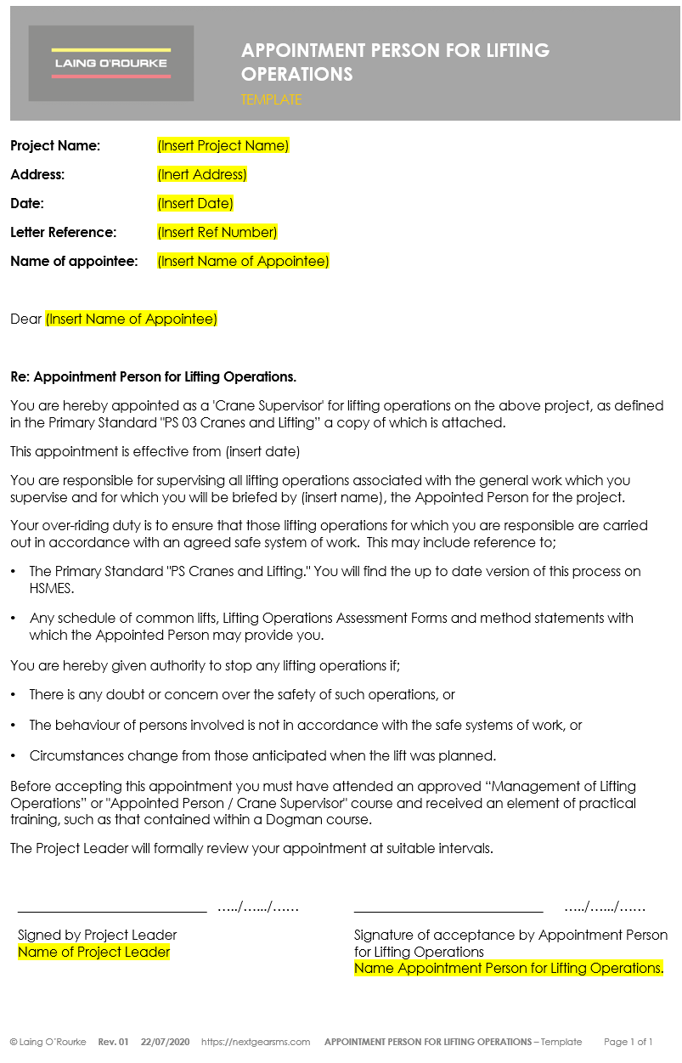

Appendix B - Appointment Laing O’Rourke Crane Supervisor
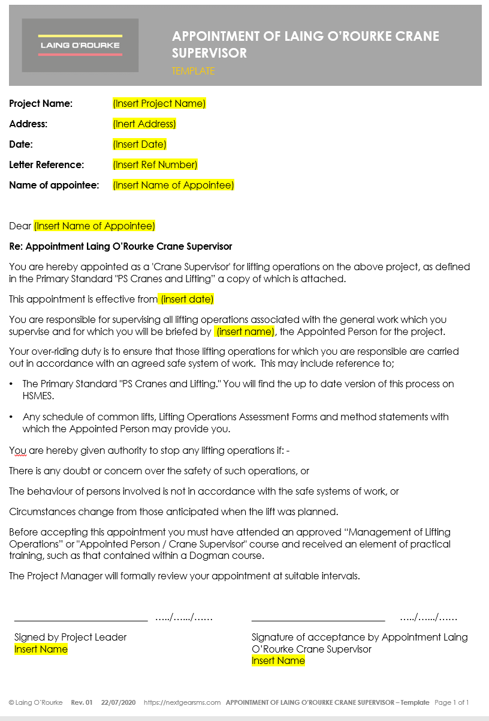

Appendix C - Crane Team Meeting Agenda Template
